User Manual
Message Notification Centre (MNC)
(Version 1.0)
Team-5

TABLE OF CONTENTS
- General Information
  - Introduction..............................................................................................3
    - Overview..........................................................................................3
    - Project Scope...................................................................................3
    - Product Perspective.........................................................................3
  - Abbreviations...........................................................................................3
- System Summary............................................................................................4
  - User Requirements...................................................................................4
- Getting Started...............................................................................................4
  - How to register to get SMS notification? .................................................4
3.2. How to Login? .........................................................................................5
3.3. Introducing new added features: ............................................................6
3.3.1Using the filter option.......................................................................6
3.3.1.1 What is Filtering Option? .....................................................6
3.3.1.2 How to use it.........................................................................6
3.3.2 FAQ’s Section...................................................................................8
4.0 How to change the mobile number? ............................................................8
5.0 How to change Password? ............................................................................9
6.0 How to Unregister? .......................................................................................9

- General Information
  - Introduction:
1.1.1Overview:
SMS Notification via webmail is facility that allows one to receive SMS alerts for new mails in webmail inbox. The product has user friendly user interface, and well documented help in form of both frequently asked questions and User Manual.

1.1.2Product Scope:
In addition to the basic functionality as mentioned above, an incremental development would include reminder system for the scheduled tasks on the calendar.

1.1.3Product Perspective:
This is a project follow-on member in some sense to the existing 71 Zimlets that have been developed by various institutes including Zimbra itself.
The text sent in the SMS would primarily contain information about the subject, and sender. This project has been inspired from the SMS functionality provided by various email vendors. The motivation, however is to prompt the students to check their webmail accounts for events that require urgent attention. True to the present day, neither does Zimbra provide any such in-built facility, nor has any other person-individual or part of any organization developed any dedicated zimlet or an application to serve the purpose.
The project is universal in its approach in that the benefits of the application are open to the faculty and the administrative department in addition to the student community at the University.
  - Abbreviations:
- SMS : Short Messaging Service
- MNC : Message Notification Centre
- DA-IICT: Dhirubhai Ambani Institute of Information and Communication Technology

2. System Summary

2.1 User Requirements:
The user must ensure the following to be able to run the application:
- Internet support
- Mail account in ZIMBRA
- A valid mobile number

3. GETTING STARTED 3.1 How to register to get SMS notification?
Follow the steps mentioned below to register:
- Click on ‘SMS Settings’ zimlet that appears in the panel. An MNC login page would appear.
- This page would have a register button. Click on it to be redirected to the registration page.
- Enter username, password as asked which should be same as that for the zimbra account. Once this is confirmed, set the mobile number field and submit. Enter the confirmation code that would be sent to your mobile to start receiving message updates.
- In case the user loses the confirmation code, the system provides for a re-send functionality. By the virtue of this functionality the user can demand for the confirmation code again for a maximum of 5 time, including the first the code was sent, after which he/she may have to wait for another 2 hours receive a confirmation code, for the re-send button to be active again.
- After logging in the setting page which can be view by clicking on the settings tab allows one to set the filter options for both the user and the subject.
- Snapshots of registration pages:
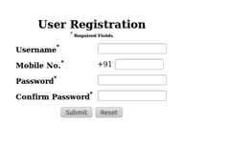
Pic1: First time registration page
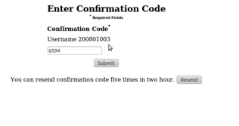
Pic2: Mobile number confirmation page that follows the registration.
Constraints on the Password:
The password for the MNC account must be same as that of the zimbra account.

3.2 How to Login?
If the user already has an MNC account then he/she must follow the steps mentioned below to login:
- Sign in zimbra. Next, click on the ‘SMS Settings’ zimlet in the panel.
- Sign in the MNC account that opens following step 1. Enter username and password.
- Left clicking on it will direct you to the Login page.
- There you can see many options like Login, Change password, register, FAQ’s and unregister.
- The login page would look similar to the snapshot shown below:
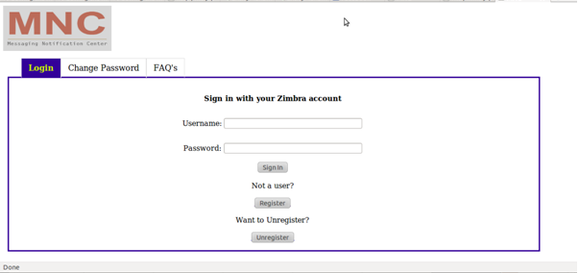

Pic3: Snapshot of login page with tabs for Changing Password and FAQs.
3.3 Introducing new added features:
3.3.1Filtering option:
3.3.1.1 What is Filtering option?
The filtering option is meant to block on the basis of subject and/or sender.
3.3.1.2 How to use it?
Follow the steps mentioned below to set filters:
- After logging in into your mail account, click on ‘SMS Settings’ in the panel.
- This would redirect you to a MNC login page where you’d see options like login, change password, register, unregister and FAQ’s. Left click on ‘login’ if you already have an account and ‘register’ if you haven’t made an account yet.
- After logging in, by default, settings option will open up. You can have different settings that you need by changing the value of respective fields. If you are on some page other than settings, on left clicking on the settings, it’ll open up the page where you can select different values for different fields to change your account settings according to your preference.
- On the settings page you’ll see the fields “Username or email address” and “Subject Keyword”:
Username or email address:
- You can enter the usernames here, for whose mails you don’t want to receive an SMS for.
- Enter the username in the username field and left click on ‘add’. All the username that you keep adding will be visible to you on the left blank space of ‘Exclude by Username’ part.
- To unblock the user select the username who has been blocked and left click on ‘delete’.
Subject Keyword:
- You can enter the subject names here, related to which you don’t want to receive an SMS.
- Enter the subject in the subject field and left click on ‘add’. All the blocked subjects would be visible to you on left blank space of ‘Exclude by Subject keyword’ part.
- To unblock the service for the mails related to a particular subject, select the subject that has been blocked and left click on ‘delete’ option to unblock the service.
- SMSs for the mails from the specified user and the SMSs related to the specified subject have now been blocked.
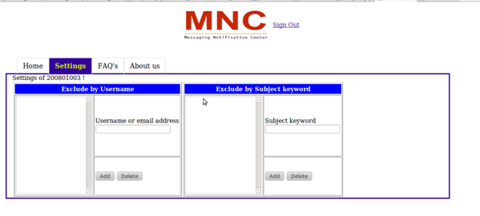

Pic4:Snapshot of filter settings page on MNC.

3.3.2 FAQ section:
FAQ section addresses frequently asked and anticipated questions from the user. A downloadable link for ‘User Manual’ has alos been provided for greater insight into the queries(since, FAQs do not exhaustively cover all the information that the user needs)

FAQs’ section is accessible from both the main page of MNC as well as from user’s home page.

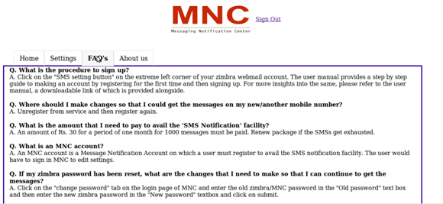

Pic5: Snapshot of FAQ page on MNC.

4.0 How to change Mobile Number?
To change the mobile number on which you want to receive the SMSs for received mails one would have to do the following:
- Unregister yourself.
- Register yourself with a new number

5.0 How to change password?
The condition where you want to change your password will only occur to you in the case where your mail account password has been changed. To change the password you have to follow following steps:
- After logging in to your mail account, go to the ‘ZIMLETS’ and left click on it if it’s not already showing the options. You’ll see the options of all the Zimlets that are installed in your account.
- Now click on the SMS settings zimlet, which will open a page where you’d see options like login, change password, register, unregister and FAQ’s.
- Left click on change password button which will open up the page where by providing the required information like username, old password, new password and confirm new password you’ll be able to change your password.
6.0 How to Unregister?
To unregister follow steps mentioned below:
1. After logging in into your mail account, click on ‘SMS Settings’ in the panel.
2. This would redirect you to a MNC login page where you’d see options like login, change password, register, unregister and FAQ’s.
3. Left clicking on Unregister option will take you to the page where by entering your username and password, you’ll be able to unregister yourself.

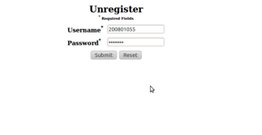
Pic6: Snapshot of unregister page on MNC.

SMS stands for Short Message Service

